Example of a custom control panel.

In regular mode , Device on the left is active

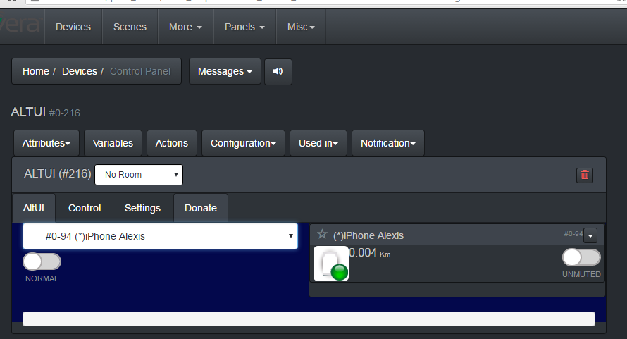

In recording mode, actions are being recorded and recorded in a “log”

The API I have built enable to get each action one by one as they happen, and/or get a complete log for all that happened during the recording mode. You can even change the device, or go into another page and it continues to record

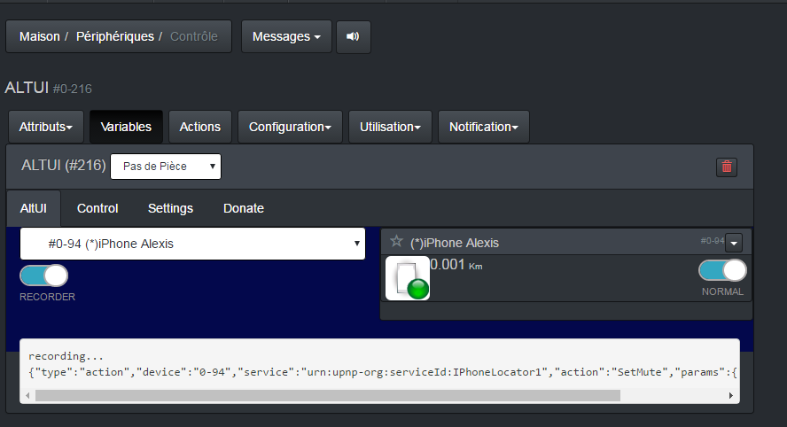

In the end you get a json array



NORMAL

#0-216

 ALTUI

_todo_

NORMAL

[

{

"type": "action",

"device": "0-94",

"service": "urn:upnp-org:serviceId:IPhoneLocator1",

"action": "SetMute",

"params": {

"newMuteStatus": 1

}

},

{

"type": "action",

"device": "0-7",

"service": "urn:upnp-org:serviceId:Dimming1",

"action": "SetLoadLevelTarget",

"params": {

"newLoadlevelTarget": 0

}

},

{

"type": "action",

"device": "0-216",

"service": "urn:upnp-org:serviceId:altui1",

"action": "SetDebug",

"params": {

"newDebugMode": 1

}

}

]

API offered by MultiBox

// Recorder

isRecording : \_isRecording, //()

startRecorder : \_startRecorder, //(callback)

stopRecorder : \_stopRecorder, // returns a log

Example of use of the API but the custom control panel for ALTUI device

function \_drawAltUIControlPanel( device, domparent) {

function \_displayOneDevice( altuiid ) {

var device = MultiBox.getDeviceByAltuiID(altuiid);

$("#altui-display-box").html( ALTUI\_Templates.deviceEmptyContainerTemplate.format(device.id,device.altuiid));

$('.altui-device[data-altuiid={0}]'.format(device.altuiid)).html( UIManager.deviceDraw(device) );

}

var devices = MultiBox.getDevicesSync();

var device = MultiBox.getDeviceByID( 0, g\_MyDeviceID );

html += "<H2>Experimental</H2>"

var html = "<div class='altui-panel-controls col-xs-6 '>";

html += DialogManager.pickDevice(devices,device.altuiid,'altui-select-device')

var \_recordMode = MultiBox.isRecording();

html += ALTUI\_PluginDisplays.createOnOffButton( \_recordMode==true ? 1 : 0,"altui-recordmode-"+device.altuiid, \_T("Normal,Recorder") , "pull-left");

html += "</div>"

html += "<div class='col-xs-6 '>";

html +="<div id='altui-display-box' class='row'>"

html += ALTUI\_Templates.deviceEmptyContainerTemplate.format(device.id,device.altuiid,'altui-norefresh col-xs-12');

html += "</div>";

html += "</div>";

html += "<div class='col-xs-12'>";

html += "<pre id='altui-record-log'></pre>"

html += "</div>";

$(domparent).append(html);

\_displayOneDevice( device.altuiid );

// interactions

$("#altui-recordmode-"+device.altuiid).closest('.altui-panel-controls')

.off()

.on('click', "#altui-recordmode-"+device.altuiid, function() {

var checked = $("#altui-recordmode-"+device.altuiid).find("input").prop('checked');

\_recordMode = !checked;

if (\_recordMode==true) {

MultiBox.startRecorder( function( action ) {

$("#altui-record-log").append( JSON.stringify(action)+'\n' )

});

$("#altui-record-log").text( "recording...\n" )

} else {

var log = MultiBox.stopRecorder();

$("#altui-record-log").text( JSON.stringify(log,null,2) )

}

$(".altui-panel-controls .altui-button-onoff").replaceWith( ALTUI\_PluginDisplays.createOnOffButton( \_recordMode==true ? 1 : 0,"altui-recordmode-"+device.altuiid, \_T("Normal,Recorder") , "pull-left") );

});

$('#altui-select-device').change(function(){

var altuiid = $(this).val();

\_displayOneDevice( altuiid )

});

};